**Title:**

Avoiding tradeoffs between global seafood production and seafloor impacts through fishery innovation

**Authors:**

T. Scott Smeltz1,2*, Christopher M. Free3, Bradley P. Harris2, Olaf P. Jensen4, Jonathan H. Grabowski5, Suresh A. Sethi2,6

**Affiliations:**

1New York Cooperative Fish and Wildlife Research Unit, Department of Natural Resources, Cornell University, Ithaca, NY 14853, USA.

2Alaska Pacific University, Fisheries, Aquatic Science and Technology (FAST) Laboratory, Anchorage, AK 99508, USA.

3Bren School of Environmental Science and Management, University of California, Santa Barbara, Santa Barbara, CA, 93106, USA.

4Department of Marine and Coastal Sciences, Rutgers University, New Brunswick, NJ, 08901, USA.

5Department of Marine and Environmental Sciences, Marine Science Center, Northeastern University, Nahant, MA 01907, USA.

6U.S. Geological Survey, New York Cooperative Fish and Wildlife Research Unit, Cornell University, Ithaca, NY 14853, USA.

*Correspondence to: ts428@cornell.edu

**Abstract:**

Wild seafood is an important contributor to global food supplies, yet fishing on the seafloor can alter benthic habitats and threaten ecosystem integrity. Here, we estimate global seafloor disturbance from fishing and quantify habitat impacts associated with maximizing seafood production to meet growing food demands. Currently 8% (3.4 million km2) of the continental shelf is impacted by fishing, a habitat tradeoff comparable to land use for terrestrial animal sourced foods. Global bottom fishing harvests could increase by 22% (9.1 million mt/year) if managed for maximum yields, but with an additional 10% increase in seafloor impacts (290,000 km2). Fishery innovations can help overcome food-impact tradeoffs and we estimate a 30% reduction in gear-seafloor interactions could offset increased seafloor disturbance associated with maximum harvests.

**One Sentence Summary:**

Fishing innovations that reduce seafloor contact can help overcome food-habitat tradeoffs as global protein demands increase.

**Main text:**

Wild harvested seafood is a key component of diets throughout the world, accounting for 8% of animal-based protein consumed globally (*1*). Human population growth coupled with increasing per capita protein consumption is projected to increase global demand for protein by as much as 50% by 2050 (*2*). Meeting this demand will require increasing production across multiple food sectors including wild capture seafood. Although commercial fisheries catches have remained relatively stable over the last several decades, recent analyses indicate that increasing global harvest may be achieved not only by improved management of overexploited stocks, but also by increasing fishing pressure on underexploited stocks (*3*). Additional harvest opportunities, however, present a challenge in managing and minimizing increased environmental impacts associated with greater seafood production.

All food sectors contend with environmental tradeoffs (*4*). Habitat conversion associated with food production systems represents a primary amplifier of climate-driven ecosystem changes and a threat to biological diversity globally (*5*). One of the most controversial environmental costs associated with wild capture fishing is disturbance to the seafloor from trawl gears which account for ~40% of all wild harvested seafood (*6*). Seafloor impacts from fishing gear include the degradation and removal of epibenthic organisms as well as the scattering of geological structural formations such as cobble piles, which provide critical refuge, spawning, and foraging grounds for marine organisms. Moreover, degradation of these habitats, commonly referred to as ecosystem impacts of fishing, may threaten the sustainability of the harvested fish species that depend on them (*7*, *8*).

Recent compilations of global fishing effort derived from the satellite monitored Automatic Identification System (AIS) have provided a view of the global extent of fishing pressure on the seafloor. These data have been used to estimate that the total footprint of all fishing activity from 2012 - 2016 covered up to 55% of the world’s oceans (*9*). However, there are limitations when estimating the scale of seafloor impacts from the global fishing effort footprint. First, the potential for seafloor impacts is dominated by trawls, whereas pelagic fishing activity, which is also recorded by AIS, results in little or no contact with the ocean bottom and thus negligible seafloor impacts. Second, typically only specific components of fishing gear used on or near the seafloor actually touch it such that the seafloor area potentially impacted during a fishing event is less than its total swept area path (*10*). Third, the organisms and geological features that create habitat structure on the seafloor demonstrate varying degrees of susceptibility to contact and capacity to recover from damage or removal (*11*). Thus, estimating seafloor disturbance – defined here as the areal extent in which benthic features have been damaged or removed by trawling and have not yet recovered to pre-trawling levels – requires a dynamic impact and recovery model that incorporates habitat specific vulnerabilities, gear characteristics, and an understanding of how gear contacts the seafloor (*12*).

Minimizing seafloor disturbance is a high priority for many of the world’s fishery management bodies (e.g. *13*, *14*) and a prerequisite for maintaining ocean ecosystem integrity (*7*). To date, marine reserves have been the primary tool to meet this objective. While marine reserves have demonstrated successes (*15*, *16*), especially when protecting highly vulnerable seafloor habitats, they can have limitations as a commercial fisheries management measure. In many cases, fishing effort is displaced elsewhere, such that spatial closures may not achieve success without other corresponding policies to reduce effort or total allowable catches (*17*). But as global demand for protein mounts with increasing human population, reducing fishery harvests as a means to control seafloor impacts may lead to a difficult tradeoff. Aside from the socioeconomic consequences of reduced harvest, there may be concomitant environmental impacts associated with producing substitute protein from other food systems, such as terrestrial crops or livestock. One means to avoid the tradeoff between benthic habitat impacts and foregone fishery harvest is to minimize seafloor disturbance by reducing gear-seafloor interactions – a direct solution that may be met through gear modifications to reduce seafloor contact from fishing, or increases in catch efficiency that maintain harvest rates but with less expended effort.

Here, we quantify seafloor impacts from fishing and explore options for navigating seafood production and environmental impact tradeoffs. We first assess the areal extent of global seafloor disturbance by trawling activities using a dynamic impact and recovery model (*12*) and compare area-based production estimates from the ocean with habitat impacts on land from equivalent terrestrial protein production. We then use catch-based stock assessment models to evaluate the potential for sustainable harvest increases from trawl fisheries globally and within large marine ecosystems (LME) to meet growing protein demands, and estimate the increase in seafloor disturbance associated with increasing fishing pressure to achieve maximum sustainable yield (MSY) under conventional gear configurations and fishing practices. Finally, we demonstrate how innovations in fishing gear technology and/or improvements in capture efficiency could reduce the effects of trawling on the seafloor and help mitigate the impacts of fishing on seafloor habitats globally.

**Results/Discussion**

We used a dynamic benthic habitat impact and recovery model (*12*) and time series of AIS-derived fishing effort data from 2013 - 2018 to estimate the current scale of global seafloor disturbance, finding that total global seafloor disturbance from trawling was 3.4 million km2 (8% of the world’s continental shelves). This estimate includes upward adjustments for ten LMEs identified as having low AIS coverage of their fleet as indicated by an anomalously low ratio between harvest and AIS-derived fishing effort as compared to well-covered LMEs (Fig. S1). The distribution of seafloor disturbance from fishing varied widely among LMEs (Fig. 1, Table S1). Eight LMEs contributed to over half of the world’s total seafloor disturbance, three of which were estimated to have >40% disturbance (Yellow Sea, Iberian Coastal, and Celtic-Biscay Shelf) within the shelf area of their LME. Ten of the world’s 66 LMEs were estimated to have <1% of their shelf area disturbed by fishing. Mid- and high-latitude LMEs in the Northern hemisphere, excluding those in the Arctic, generally had higher levels of seafloor disturbance than low-latitude and Southern hemisphere LMEs. The highest concentrations of LMEs with high disturbance (>25% of shelf area) were in European waters and eastern Asia waters. Arctic and Antarctic LMEs had relatively low levels of disturbance (<5%) with the exception of the Barents and Norwegian Seas (Arctic LMEs), which were estimated to have approximately 14% of their shelf area disturbed by fishing.

This disturbance to the seafloor associated with fishing is an environmental cost of harvesting over 40 million mt of seafood (including both reported and reconstructed catches) (*6*) from the world’s oceans each year by trawls. Globally, this amounts to 11.9 mt of seafood harvested per km2 of seafloor disturbed, though the efficiency of this tradeoff is highly variable among LMEs (Fig. 1 inset). Recognizing that terrestrial land use for food production poses ecological consequences that differ substantially from those incurred from seafloor disturbance, comparisons of habitat impact vs. protein production tradeoffs among key animal production systems provides insight into the opportunity cost of foregone wild capture fisheries production. The edible protein yield of seafood (conventionally measured in megagrams, Mg, equivalent to 1 metric ton) averages about 11% of the live weight of fish caught (*18*) resulting in an average of 1.3 Mg edible protein harvested per km2 of seafloor disturbed for bottom trawl fisheries annually. When comparing the amount of habitat impacted from these protein sources, we estimate that protein harvested from the seafloor to be about three times more efficient than beef sourced protein (0.41 Mg edible protein per km2, including land used for pasturing and feed crops), but about one-tenth the efficiency of pork or poultry (each yield 11 Mg edible protein per km2, including land used for feed crops) (*19*).

As the human population grows to a projected 10 billion people over the coming three decades (*20*), pressure will mount to increase production across food sectors to meet protein demands (*21*, *22*). Using a catch-based stock assessment model to evaluate current exploitation rates of fishing on the seafloor (*23*), we found that over 83% of the trawl-caught stocks included in the analysis (1,716 of 2,070 stocks) are currently harvested at rates below that associated with MSY (Fig. S2). We estimate that maximum utilization of these stocks, along with rebuilding the 20% of overfished stocks, has the potential to sustainably increase trawl harvest by 22% over current levels, an approximately 9.1 million mt per year harvest increase (1.0 million Mg of additional protein per year). In four LMEs, trawl fisheries as a group are currently overfishing and would require reductions in effort to achieve MSY, presenting opportunities to simultaneously increase harvest in some regions while also reducing seafloor disturbance. However, increasing catches in most LMEs would require additional fishing effort (Fig. 2). Aggregating across all assessed stocks, net global trawl fishing effort would need to increase by 45%, adding over 8 million additional hours of fishing to the world’s oceans each year. Under an assumption that this increase in fishing effort would be distributed in proportion to past fishing effort, the cumulative additional impacts on the seafloor would be correspondingly less, increasing total seafloor disturbance by 10% (>290,000 km2, equivalent to an area the size of Italy) as fishing impacts often overlap in space with already disturbed habitat (*12*).

While global trawl fisheries have potential for higher harvests, under current fishing practices, increases in seafood from these resources will present a tradeoff between accepting additional seafloor impacts across most LMEs, or alternatively, shifting this foregone harvest to land-based food systems to meet future protein demands. For example, to supply the 1 million Mg of additional protein harvested if MSY were achieved with beef-sourced protein would require an additional 2.4 million km2 of land devoted to pasture and agricultural land for feed; pork and poultry would require 90,000 km2 of additional agricultural land for feed. However, it may be possible to avoid this impasse through innovations that allow trawl harvest to increase without incurring additional impacts to the seafloor. Two approaches show promise in this regard.

First, opportunities exist to modify fishing gears to reduce seafloor contact, while still maintaining catch performance. For example, a simple gear modification of attaching small spherical lifting ‘bobbins’ to the sweeps of a bottom trawl has been demonstrated to reduce seafloor contact by up to 95% without significant effect on the catch efficiency of targeted groundfish in large North Pacific fisheries (*10*) (Fig. 3, A). In other examples, novel trawl door designs have been used to dramatically reduce bottom contact of trawl gear components (*24*, *25*) (Fig. 3, B), and newly developed pulse trawls utilize electrical pulses to stimulate groundfish or shrimp upwards for capture above the seafloor (*26*) (Fig. 3, C). Second, policies or technologies that increase catch efficiency such that less effort is expended per unit harvest can reduce seafloor impact in attaining prescribed catches. By aligning economic incentives with long term sustainable fishing practices, dedicated access privileges based fisheries management helps avoid wasteful fishing practices and reduce the fishing effort needed to achieve a given catch (*27*). For instance, upon transitioning to individual harvest quota-based management, total days at sea for Nova Scotia offshore scallop decreased by 15 – 20% (*28*). On the other hand, management approaches that reduce the efficiency of fishing - such as marine protected areas located in productive fishing grounds (*29*)- have the potential to inadvertently increase effort to achieve target catches, resulting in an increase in the area of seafloor impacted per unit of fish harvested.

Through innovative approaches to modify fishing gear or increase catch efficiency, it may be possible to significantly reduce the seafloor impact of trawl fisheries at seascape scales. Using the global dynamic impact and recovery model and aggregating across LMEs, we find that MSY harvest levels from trawls could be achieved with no net increase in aggregate seafloor impact if fleets were to employ gears with 30% less contact, increase CPUE by 33%, or combine both efforts in lesser extents (Fig. 3, D). Regardless of future catch targets, innovations to reduce seafloor contact would be beneficial for reducing ocean ecosystem impacts from fishing under current harvest levels. For example, we estimate that fishing gear modifications that lead to a relatively small 10% reduction in bottom contact would lead to a global reduction of 136,000 km2 of seafloor disturbance, whereas a 50% reduction in contact—within the limits of existing successful gear modification experiments—would spare 782,000 km2 of seafloor disturbance across the world’s continental shelves.

While the rising cost of land has driven dramatic land use efficiency improvements in terrestrial-based animal protein systems over the last half century (*30*), fisheries innovations have progressed at a slower pace. Impediments to fisheries innovations are both economic and regulatory; however, solutions to catalyze progress in many fisheries are already available. The costs to research and implement new fishing technologies can be high, especially for undercapitalized fisheries, but growing activity in conservation finance (*31*) may provide capital to accelerate technological advances. Similarly, fisheries governance reforms that align economic incentives with reductions in seafloor impacts through individual habitat quotas may spur gear and fishing practice innovations among fishers (*32*).

**References and Notes:**

1. FAO, *The State of World Fisheries and Agriculture 2018 - Meeting the sustainable development goals* (Rome, Licence: C., 2018).

2. N. Alexandratos, J. Bruinsma, “World agriculture towards 2030/2050: the 2012 revision” (Rome, FAO, 2012).

3. R. Hilborn, C. Costello, The potential for blue growth in marine fish yield , profit and abundance of fish in the ocean. *Mar. Policy*. **87**, 350–355 (2018).

4. R. Hilborn, J. Banobi, S. J. Hall, T. Pucylowski, T. E. Walsworth, The environmental cost of animal source foods. *Front. Ecol. Environ.* **16**, 329–335 (2018).

5. T. Newbold, L. N. Hudson, S. L. L. Hill, S. Contu, I. Lysenko, R. A. Senior, L. Börger, D. J. Bennett, A. Choimes, B. Collen, J. Day, A. De Palma, S. Díaz, S. Echeverria-Londoño, M. J. Edgar, A. Feldman, M. Garon, M. L. K. Harrison, T. Alhusseini, D. J. Ingram, Y. Itescu, J. Kattge, V. Kemp, L. Kirkpatrick, M. Kleyer, D. L. P. Correia, C. D. Martin, S. Meiri, M. Novosolov, Y. Pan, H. R. P. Phillips, D. W. Purves, A. Robinson, J. Simpson, S. L. Tuck, E. Weiher, H. J. White, R. M. Ewers, G. M. MacE, J. P. W. Scharlemann, A. Purvis, Global effects of land use on local terrestrial biodiversity. *Nature*. **520**, 45–50 (2015).

6. D. Pauly, D. Zeller, Sea Around Us Concepts, Design and Data (2015), (available at seaaroundus.org).

7. L. Watling, E. A. Norse, Disturbance of the seabed by mobile fishing gear: a comparison to forest clearcutting. *Conserv. Biol.* **12**, 1180–1197 (1998).

8. E. K. Pikitch, C. Santora, E. A. Babcock, A. Bakun, R. Bonfil, D. O. Conover, P. Dayton, P. Doukakis, D. Fluharty, B. Heneman, E. D. Houde, J. Link, P. A. Livingston, M. Mangel, M. K. McAllister, J. Pope, K. J. Sainsbury, Ecosystem-based fishery management. *Science*. **305**, 346–347 (2004).

9. D. A. Kroodsma, J. Mayorga, T. Hochberg, N. A. Miller, K. Boerder, F. Ferretti, A. Wilson, B. Bergman, T. D. White, B. A. Block, P. Woods, B. Sullivan, C. Costello, B. Worm, Tracking the global footprint of fisheries. *Science*. **359**, 904–908 (2018).

10. C. S. Rose, J. R. Gauvin, C. F. Hammond, Effective herding of flatfish by cables with minimal seafloor contact. *Fish. Bull.* **108**, 136–144 (2010).

11. J. H. Grabowski, M. Bachman, C. Demarest, S. Eayrs, B. P. Harris, V. Malkoski, D. Packer, D. Stevenson, Assessing the vulnerability of marine benthos to fishing gear impacts. *Rev. Fish. Sci. Aquac.* **22**, 142–155 (2014).

12. T. S. Smeltz, B. P. Harris, J. Olson, S. A. Sethi, A seascape scale habitat model to support management of fishing impacts on benthic ecosystems. *Can. J. Fish. Aquat. Sci.* **9**, 1–9 (2019).

13. *Magnuson- Stevens Act Provisions; Essential Fish Habitat (EFH). 50 CFR part 600. U.S. Federal Register, vol.67* (2002).

14. *Directive 2008/56/EC of the European Parliament and of the Council of 17 June 2008 establishing a framework for community action in the field of marine environmental policy (Marine Strategy Framework Directive)* (2008).

15. G. J. Edgar, R. D. Stuart-Smith, T. J. Willis, S. Kininmonth, S. C. Baker, S. Banks, N. S. Barrett, M. A. Becerro, A. T. F. Bernard, J. Berkhout, C. D. Buxton, S. J. Campbell, A. T. Cooper, M. Davey, S. C. Edgar, G. Försterra, D. E. Galván, A. J. Irigoyen, D. J. Kushner, R. Moura, P. E. Parnell, N. T. Shears, G. Soler, E. M. A. Strain, R. J. Thomson, Global conservation outcomes depend on marine protected areas with five key features. *Nature*. **506**, 216–20 (2014).

16. S. E. Lester, B. S. Halpern, K. Grorud-Colvert, J. Lubchenco, B. I. Ruttenberg, S. D. Gaines, S. Airam??, R. R. Warner, Biological effects within no-take marine reserves: A global synthesis. *Mar. Ecol. Prog. Ser.* **384**, 33–46 (2009).

17. S. P. R. Greenstreet, H. M. Fraser, G. J. Piet, Using MPAs to address regional-scale ecological objectives in the North Sea: Modelling the effects of fishing effort displacement. *ICES J. Mar. Sci.* **66**, 90–100 (2009).

18. Torry Research Station Aberdeen (UK), Yield and nutritional value of the commercially more important fish species. *FAO Fish. Tech. Pap. No. 309* (1989), p. 187.

19. M. Herrero, S. Wirsenius, B. Henderson, C. Rigolot, P. Thornton, P. Havlík, I. de Boer, P. Gerber, Livestock and the Environment: What Have We Learned in the Past Decade? *Annu. Rev. Environ. Resour.*, 177–202 (2015).

20. United Nations Department of Economic and Social Affairs Population Division, “Department of Economic and Social Affairs. World Population Prospects 2019.” (2019), (available at http://www.ncbi.nlm.nih.gov/pubmed/12283219).

21. B. S. Halpern, R. S. Cottrell, J. L. Blanchard, L. Bouwman, H. E. Froehlich, J. A. Gephart, N. S. Jacobsen, C. D. Kuempel, P. B. McIntyre, M. Metian, D. D. Moran, K. L. Nash, J. Többen, D. R. Williams, Putting all foods on the same table: Achieving sustainable food systems requires full accounting. *Proc. Natl. Acad. Sci. U. S. A.* **116**, 18152–18156 (2019).

22. C. Costello, L. Cao, S. Gelcich, “The Future of Food from the Sea” (Washington, DC, 2019), (available at www.oceanpanel.org/future-food-sea).

23. C. M. Free, O. P. Jensen, Robin Hood cMSY: using catch data and borrowed information to assess data-poor fish stocks (2020), , doi:https://doi.org/10.5281/zenodo.3866384.

24. M. J. McHugh, M. K. Broadhurst, D. J. Sterling, R. B. Millar, Relative benthic disturbances of conventional and novel otter boards and ground gears. *Fish. Sci.* (2019), doi:10.1007/s12562-019-01392-2.

25. C. Balash, D. Sterling, M. Broadhurst, A. Dubois, M. Behrel, in *Proceedings of the 34th International Conference on Ocean, Offshore and Arctic Engineering: May 31-June 5, 2015, St. John’s, Newfoundland, Canada* (American Society of Mechanical Engineers, New York, NY, 2015).

26. P. He, P. D. Winger, in *Behavior of Marine Fishes: Capture Processes and Conservation Challenges.*, P. He, Ed. (Wiley-Blackwell, Singapore, 2010), pp. 295–314.

27. T. E. Essington, M. C. Melnychuk, T. A. Branch, S. S. Heppell, O. P. Jensen, J. S. Link, S. J. D. Martell, A. M. Parma, J. G. Pope, A. D. M. Smith, Catch shares, fisheries, and ecological stewardship: A comparative analysis of resource responses to a rights-based policy instrument. *Conserv. Lett.* **5**, 186–195 (2012).

28. Brander, Burke, Rights-based vs. competitive fishing of sea scallops *Placopecten magellanicus* in Nova Scotia. *Aquat. Living Resour.* **8**, 279–288 (1995).

29. R. Hilborn, K. Stokes, J. Maguire, T. Smith, L. W. Botsford, M. Mangel, A. Parma, J. Rice, J. Bell, K. L. Cochrane, S. Garcia, S. J. Hall, G. P. Kirkwood, K. Sainsbury, G. Stefansson, C. Walters, When can marine reserves improve fisheries management? *Ocean Coast. Manag.* **47**, 197–205 (2004).

30. H. H. E. van Zanten, H. Mollenhorst, C. W. Klootwijk, C. E. van Middelaar, I. J. M. de Boer, Global food supply: land use efficiency of livestock systems. *Int. J. Life Cycle Assess.* **21**, 747–758 (2016).

31. T. P. Fitzgerald, P. R. Higgins, E. Quilligan, S. A. Sethi, J. Tobin‐de la Puente, Catalyzing fisheries conservation investment. *Front. Ecol. Environ.*, 1–8 (2020).

32. D. Holland, K. E. Schnier, Individual habitat quotas for fisheries. *J. Environ. Econ. Manage.* **51**, 72–92 (2006).

33. R. O. Amoroso, C. R. Pitcher, A. D. Rijnsdorp, R. A. McConnaughey, A. M. Parma, P. Suuronen, O. R. Eigaard, F. Bastardie, N. T. Hintzen, F. Althaus, S. J. Baird, J. Black, L. Buhl-Mortensen, A. B. Campbell, R. Catarino, J. Collie, J. H. Cowan, D. Durholtz, N. Engstrom, T. P. Fairweather, H. O. Fock, R. Ford, P. A. Gálvez, H. Gerritsen, M. E. Góngora, J. A. González, J. G. Hiddink, K. M. Hughes, S. S. Intelmann, C. Jenkins, P. Jonsson, P. Kainge, M. Kangas, J. N. Kathena, S. Kavadas, R. W. Leslie, S. G. Lewis, M. Lundy, D. Makin, J. Martin, T. Mazor, G. Gonzalez-Mirelis, S. J. Newman, N. Papadopoulou, P. E. Posen, W. Rochester, T. Russo, A. Sala, J. M. Semmens, C. Silva, A. Tsolos, B. Vanelslander, C. B. Wakefield, B. A. Wood, R. Hilborn, M. J. Kaiser, S. Jennings, Bottom trawl fishing footprints on the world’s continental shelves. *Proc. Natl. Acad. Sci.* **115**, 201802379 (2018).

34. B. S. Halpern, S. Walbridge, K. a Selkoe, C. V Kappel, F. Micheli, C. D’Agrosa, J. F. Bruno, K. S. Casey, C. Ebert, H. E. Fox, R. Fujita, D. Heinemann, H. S. Lenihan, E. M. P. Madin, M. T. Perry, E. R. Selig, M. Spalding, R. Steneck, R. Watson, A global map of human impact on marine ecosystems. *Science*. **319**, 948–52 (2008).

35. J. G. Hiddink, S. Jennings, M. Sciberras, C. L. Szostek, K. M. Hughes, N. Ellis, A. D. Rijnsdorp, R. A. McConnaughey, T. Mazor, R. Hilborn, J. S. Collie, C. R. Pitcher, R. O. Amoroso, A. M. Parma, P. Suuronen, M. J. Kaiser, Global analysis of depletion and recovery of seabed biota after bottom trawling disturbance. *Proc. Natl. Acad. Sci.* **114**, 8301–8306 (2017).

36. N. A. J. Graham, K. L. Nash, J. T. Kool, Coral reef recovery dynamics in a changing world. *Coral Reefs*. **30**, 283–294 (2011).

37. S. Martell, R. Froese, A simple method for estimating MSY from catch and resilience. *Fish Fish.* **14**, 504–514 (2013).

38. R. Froese, N. Demirel, G. Coro, K. M. Kleisner, H. Winker, Estimating fisheries reference points from catch and resilience. *Fish Fish.* **18**, 506–526 (2017).

39. D. Ricard, C. Minto, O. P. Jensen, J. K. Baum, Examining the knowledge base and status of commercially exploited marine species with the RAM Legacy Stock Assessment Database. *Fish Fish.* **13**, 380–398 (2012).

40. J. T. Thorson, T. A. Branch, O. P. Jensen, Using model-based inference to evaluate global fisheries status from landings, location, and life history data. *Can. J. Fish. Aquat. Sci.* **69**, 645–655 (2012).

**Acknowledgements:**

We thank D. Kroodmsa and T. Clavelle of Global Fishing Watch for supplying AIS fishing data. We are grateful to R. Murphy, D. Verna, and A. Kroska for comments that improved this piece.

**Funding:**

This work was funded by the Atkinson Center Academic Venture Fund, the Guani Family Fellowship in Conservation Biology, and the Alaska Education Tax Credit funds through the Groundfish Forum and the Pollock Conservation Cooperative.

**Author contributions:**

T. S. S., S. S., B. H., and O.J. conceived of the project. T.S.S. conducted the seafloor disturbance analyses. C.F. conducted the catch-only stock assessment analyses. All authors contributed to the writing.

**Competing interests:**

Authors declare no competing interests.

**Data and materials availability:**

The fishing effort data that support the findings of this study are available Global Fishing Watch [<https://globalfishingwatch.org/>] and the fishery catch data are available from Sea Around US [<http://www.seaaroundus.org/>].

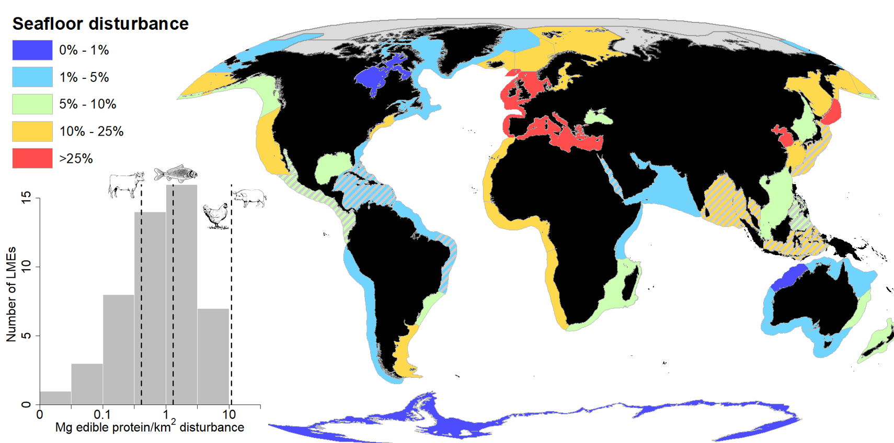

Figure 1. Seafloor disturbance (% of continental shelf area) throughout the world’s Large Marine Ecosystems (LMEs). Hashed areas show LMEs with low AIS coverage for which fishing effort was estimated using an upward adjustment procedure. The inset figure shows habitat-use efficiency (Mg edible protein produced per km2 of disturbed habitat) on log10 scale associated with bottom-tendered fisheries for the world’s LMEs. Dashed vertical lines show the global habitat use efficiency for fishing across LMEs, as well as reported values for worldwide beef production (generally less efficient) and pork and poultry production (more efficient)(*19*).

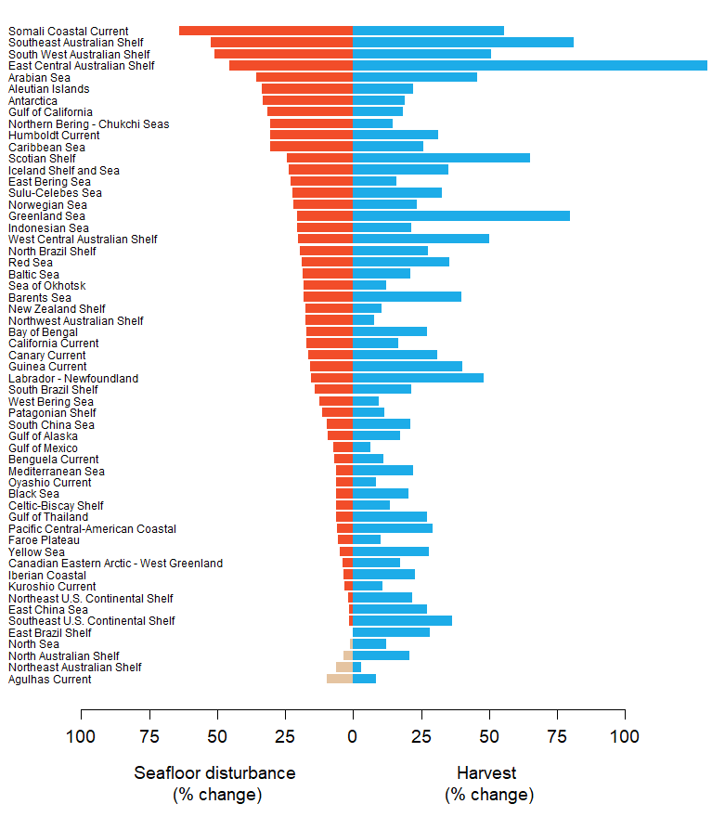

Figure 2. Tradeoffs between increased bottom-tendered fishery harvest and seafloor disturbance among the world’s Large Marine Ecosystems (LMEs). Increases in LMEs seafloor disturbance depend on both the amount of effort needed to achieve maximum sustainable yields (MSY) and the spatial distribution of effort, where more concentrated fishing effort can lead to incrementally lower increases in areas impacted relative to regions with more diffusely spread effort. Blue bars show the percent increase in yearly harvest at MSY fishing over current harvest level. Red bars show the estimated percent increase in seafloor disturbance over current levels. Tan bars indicate a percent reduction in seafloor disturbance for four LMEs currently fishing above MSY in which case reducing fishing effort would lead to both increased harvest and reduced habitat impacts.

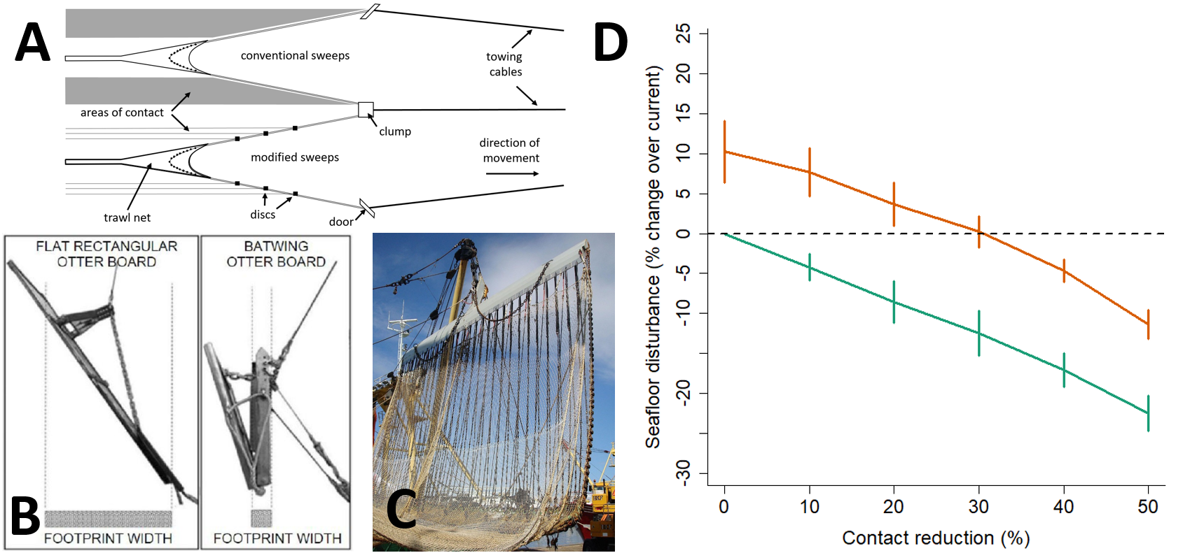

Figure 3. Gear modifications and their effect on global seafloor disturbance. Panels A, B, and C show examples of recently developed gear modifications that reduce seafloor contact. Panel A is a drawing of a groundfish trawl equipped with conventional sweeps compared to one outfitted with bobbins (reproduced with permission from (*10*)). Panel B shows a conventional trawl door compared to a modified (“batwing”) trawl door (reproduced with permission from (*25*)). Panel C shows a pulse trawl which uses electrical pulses instead of direct contact with the seafloor to stimulate fish (photo by I. Wilms). Panel D shows estimated change in global seafloor disturbance (% change over current) under a range of contact reduction scenarios; zero contact reduction indicates seafloor disturbance under current fishing practices. The green line shows the seafloor disturbance scenarios under current fishing levels in which global trawl harvest remains stable relative to 2013-2018 harvest rates, whereas the orange line indicates disturbance scenarios under global bottom-tendered fishing associated with maximum sustainable yields. Vertical bars give two standard errors reflecting year-to-year variability in simulated fishing effort.